**SOTERIA PROJECT**

# DEVELOPMENT OF A BLACK BOX SYSTEM FOR VUILNERABLE SUBJECTS ON THE ROAD

## FIRST UPDATE ON THE PROGRESS

**AUTHORS**: HAIDER ALI KHAN AND ADNAN AL SAID

**DATE:** 04/04/2024

# TABLE OF CONTENT

Contents

DEVELOPMENT OF A BLACK BOX SYSTEM FOR VUILNERABLE SUBJECTS ON THE ROAD 1

FIRST UPDATE ON THE PROGRESS 1

TABLE OF CONTENT 2

INITIAL SETUP 3

Aim of the project. 3

Type of data collected. 3

Users condition 3

Environmental condition 3

Vehicle condition 3

First solution. 3

Hardware received. 4

SYSTEM IMPLEMENTATION 6

Setup of the raspberry pi. 6

Air sensor integration. 6

Pulse sensor integration. 8

Lidar sensor integration. 9

SECOND SETUP 11

Lidar implementation. 11

Sources. 11

Connections. 11

Programming and data visualisation. 11

Second system architecture. 12

Second system output. 13

NEXT STAGES 15

DEVICE USAGE METHOD 15

Access to the system. 15

CONCLUSION 21

# INITIAL SETUP

## Aim of the project.

The project aim was presented by the Dr Suresh Renukappa from University of Wolverhampton. This consists of developing a device to monitor and collect date surrounding vulnerable users on the road. The data collected from multiple users across the country will be used to find the causes of the incidents.

The device will be developed primarily for cyclist and will be mounted on aa bicycle via custom mount.

## Type of data collected.

The device must retrieve information from the following categories: the user’s condition, the environmental condition and the condition of the vehicle.

### Users condition

The data collected from the user will display their mental and/or physical conditions. This could be the heartbeat, body temperature, focus level etc.

### Environmental condition

This type of data will reflect the scenario and the environmental condition the user was exposed to. This could be the temperature, presence of harmful gases, quality of air, ambient light noise etc.

### Vehicle condition

This type of information is essential to determine the vehicle’s condition. This could be the distance of the obstacles around, the speed and inclination, vibrations to measure shocks and mechanical stress levels etc.

## First solution.

The solution that was initially adopted by the university lecturers was to use the Raspberry Pi as the main microcontroller to collect and elaborate all the raw data from various sensor. The sensors adopted were a camera, accelerometer and gyroscope, temperature sensor, GPS and few other.

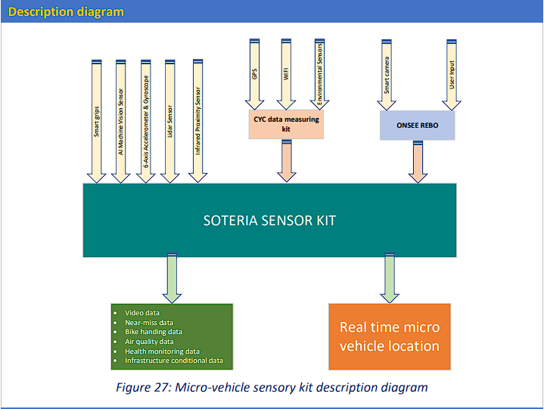

### Hardware received.

The first hardware received are:

* Raspberry pi 4.
* SD card 32GB 10th gen.
* Ultrasonic distance sensors.
* Gyroscope and Accelerometer.
* GPS module.
* Power bank.
* Barometer.

At that stage it was decided to collect one type of data form the three categories due to the tight deadline:

* Pulse sensor for the user condition.
* Air quality monitoring for the environmental condition.
* Obstacle detection for the vehicle condition.

Since those type of sensor was not present, research was conducted to achieve the best sensor quality in the shortest time possible. Therefore, the following hardware was requested:

* Amped analogue pulse sensor.
* 360 LIDAR sensor.
* Air quality sensor.

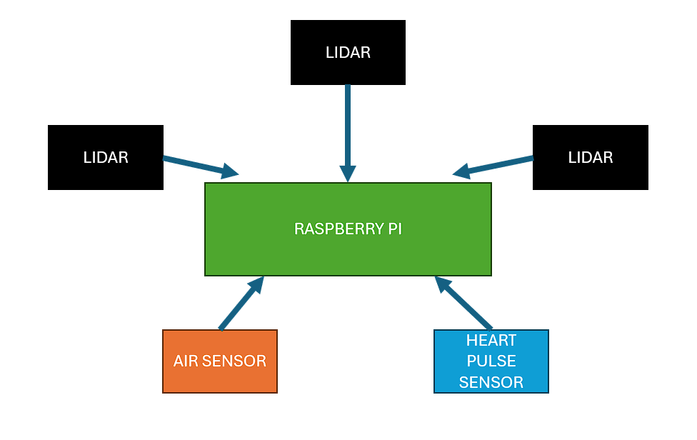

# SYSTEM IMPLEMENTATION

### Setup of the raspberry pi.

Due to the lack of an external monitor, keyboard, and mouse, it was decided to configure the raspberry pi 4 as a headless station. To do so it was vital to enable the correct option for remote access during the firmware flashing. Choosing the firmware, it is a critical part that affects the system integration, at the beginning the main and recommended OS was selected. However, this might be changed in the future to select an OS with more compatibility for hardware and software integration for various sensors.

While using the pi as a headless module the following issue were encountered: overheating of the board, latency, and lag of the connection between the board and the computer. The solutions to those problems were quite simple which involved using a standard pi setup with monitor, keyboard and mouse to compensate the lag and delays of the system and to install heatsinks on the sensitive ICs of the pi.

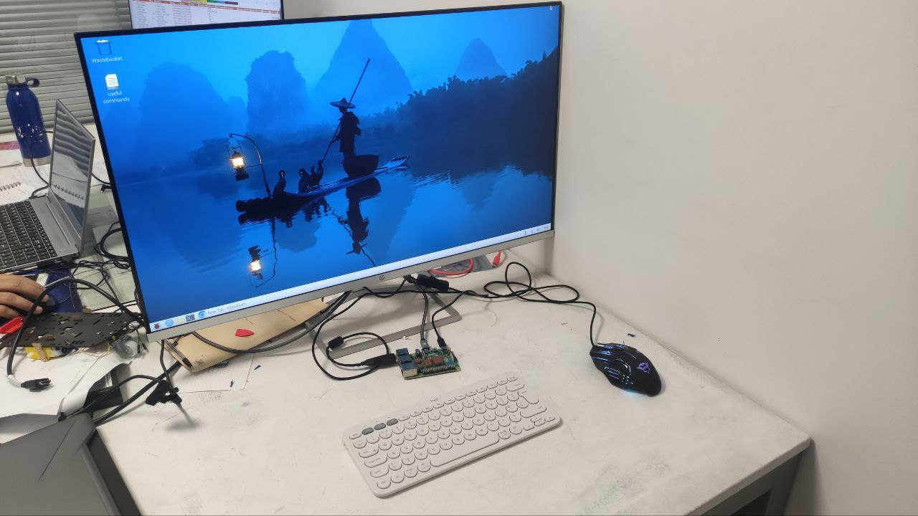

### Air sensor integration.

The BME688 air quality sensor, equipped with AI-enhanced gas scanning capabilities, accurately measures temperature, pressure, humidity, and detects volatile compounds like VOCs and VSCs. Integrated with the Breakout Garden system and Raspberry Pi, it enables comprehensive environmental monitoring and analysis, facilitating ventilation assessment and project development. Its compatibility with various microcontrollers and HATs ensures versatile integration for diverse applications.

It uses the I2C protocol, and the data was successfully retrieved from the sensor using a Python script. It was noticed that even if the connection is successful, the data read is not stable and accurate as it fluctuates or it stops being updated.

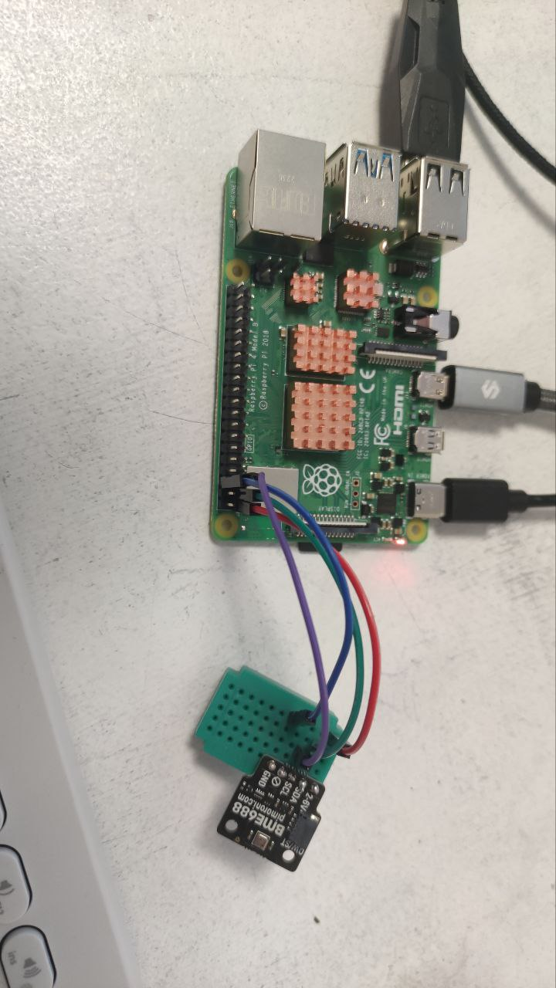

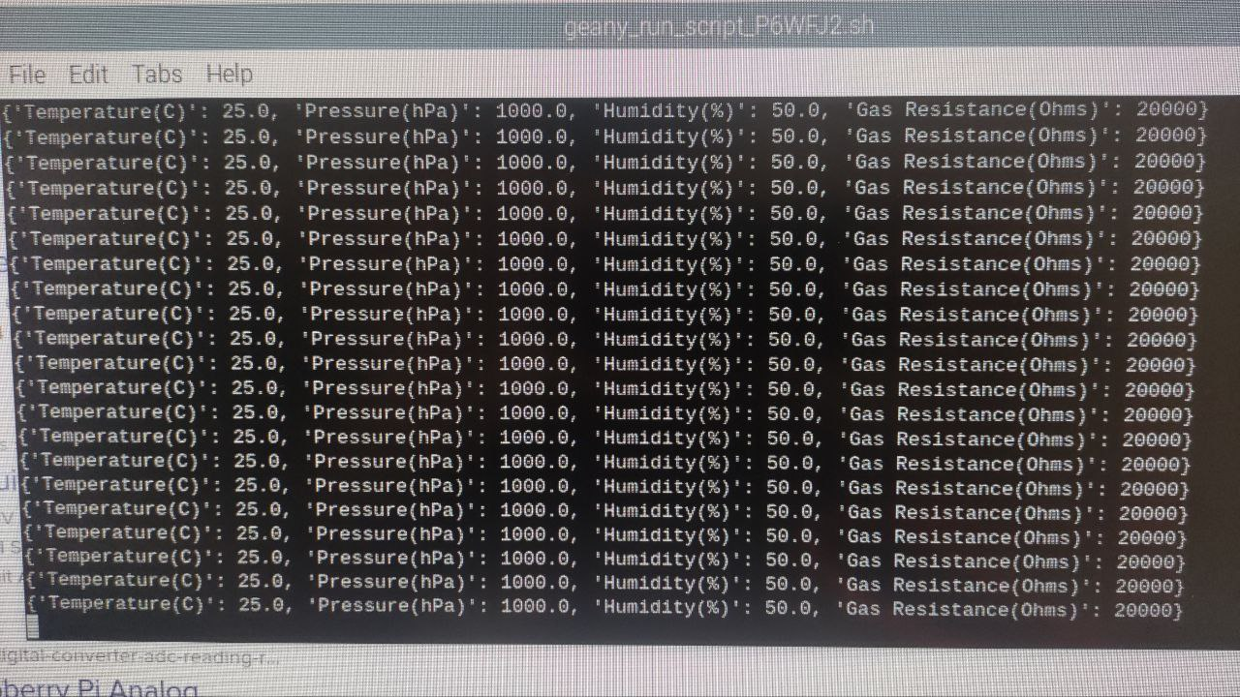

### Pulse sensor integration.

The Pulse Sensor Amped, an upgraded version of the original Pulse Sensor, offers a plug-and-play solution for incorporating real-time heart-rate data into projects for Arduino and its compatibles, appealing to students, artists, athletes, makers, and developers. With added amplification and noise cancellation circuitry, it provides faster and more reliable pulse readings, compatible with both 3V and 5V Arduinos. Additionally, enhancements to the accompanying Processing visualization software and Arduino code further improve usability and performance.

Since the pi does not have a built-in ADC, an Arduino Uno was connected to the pi to utilise one of the analogue input pins. The hardware and software integration were successful as the data retrieved was matching the heartbeat of the user.

It is planned to remove the Arduino Uno and replace it with a standalone ADC chip to simplify the cost and complexity of the hardware.

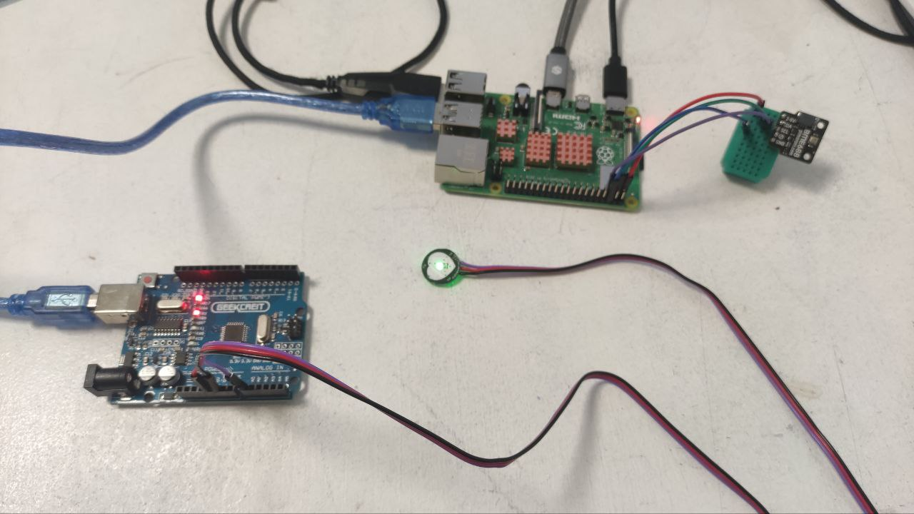

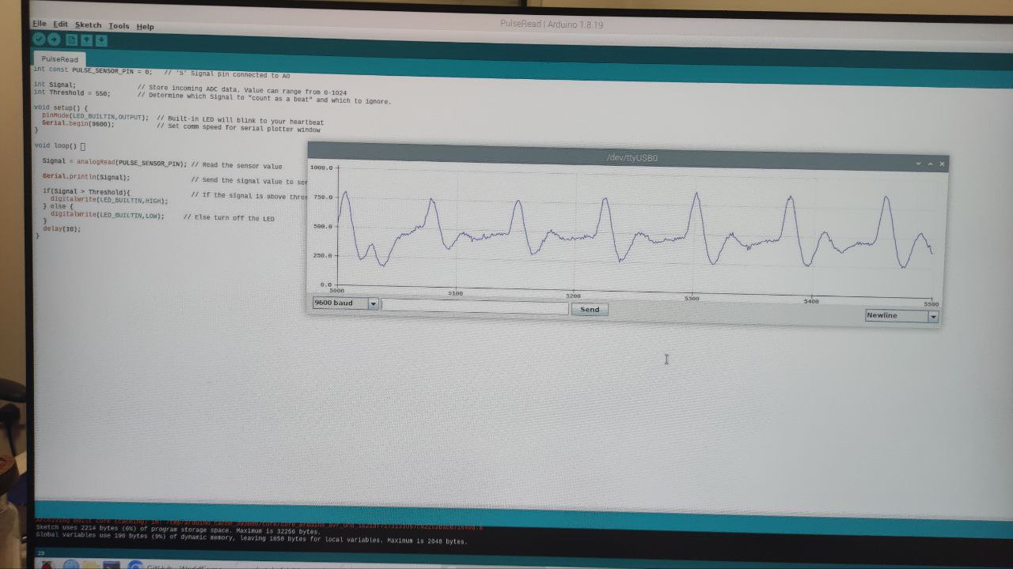

### Lidar sensor integration.

Lidar (Light Detection and Ranging) employs laser targeting and time measurement to determine distances by measuring the reflected light from objects or surfaces. This Lidar model rotates clockwise, scanning the environment with a 360° omnidirectional laser, using triangulation technology to achieve rapid distance measurements of up to 23,000 times per second. The LD14P variant extends sensing range to 8 meters, enhancing its utility for mapping and navigation tasks. Featuring start/stop control, glass wall detection, robust ambient light tolerance, and a lightweight design, this Lidar kit offers versatile functionality and easy integration into various projects.

This has been one of the hardest parts of the project due to the lack of documentation available online and the many incompatibilities of the software used by the LIDAR with the OS of raspberry. It was decided to install ROS to build an environment where the LIDAR would map the shape of surroundings using the angle and distance of the data retrieved.

The Jupiter IDE was installed for this scope and the data was retrieved via USB since the UART protocol can be converted to serial with a TTL converted provided by the manufacturer.

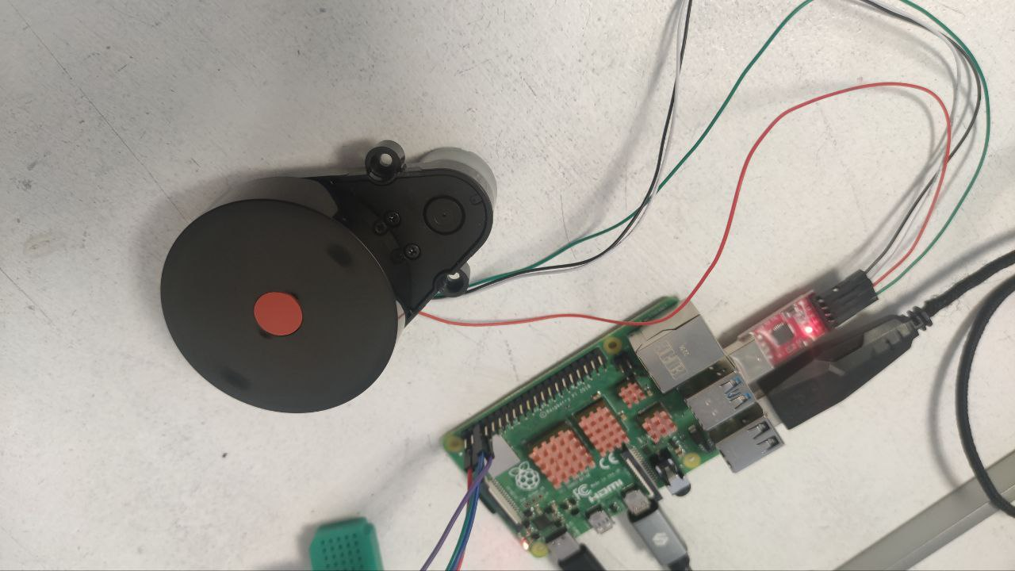

# SECOND SETUP

## Lidar implementation.

### Sources.

It was managed to find one datasheet that contained all the data regarding the Lidar D200. There were not many other resources available for this product. Here are some key parameters of the device: the distance range is 15 cm to 8 m, the scanning frequency ranges from 2 Hz to 8 Hz and 6 Hz is the default, the ranging frequency is 4 KHz. The packet sent by the Lidar are organised by the following format: Start Character> Verification Length> Lidar Rotation Speed> Start Angle> Data > End Angle> Time Stamp> Parity Check. In this document, it will not be discussed in detail the nature of each type of data as this process is already available in the datasheet.

### Connections.

As mentioned previously, the Lidar transmit packets via UART, however, in this setup a UART to TTL converter was used. This made it easier to connect the Lidar to the Raspberry pi as only plugging and unplugging the USB connector was required.

### Programming and data visualisation.

Extrapolating the raw data coming out the device was done by directly reading the data packets available in the USB port where the Lidar was connected to. The raw data is not easy to understand, so an algorithm was developed to plot the angle and distance on a radian graph.

The displaying of the data was challenging as the data was noisy and the Lidar was sending only a certain number of packets that is not possible to control. Each cycle would send the distances of about 6 to 8 angles. The angles read by the Lidar are not decided by the user, so there was no control over which angles you were able to read. This made the whole system very slow to get a full 360-degree mapping in static condition as it would take more than two minutes to do so.

To counter this issue, many approaches were used such as: implanting a moving average to get more reliable data, approximate the angle received to an integer to get a cleaner graph and more reliable representation of the distances. Nonetheless, the system is still not fast enough to respond to emergencies like near miss collisions with the vulnerable user. Therefore, it was decided to abandon the development of the Lidar module.

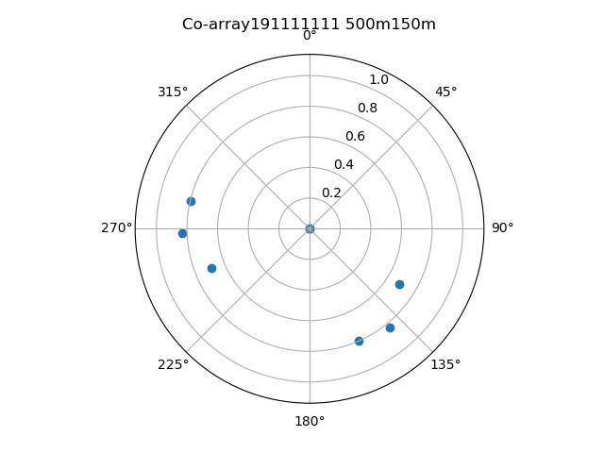

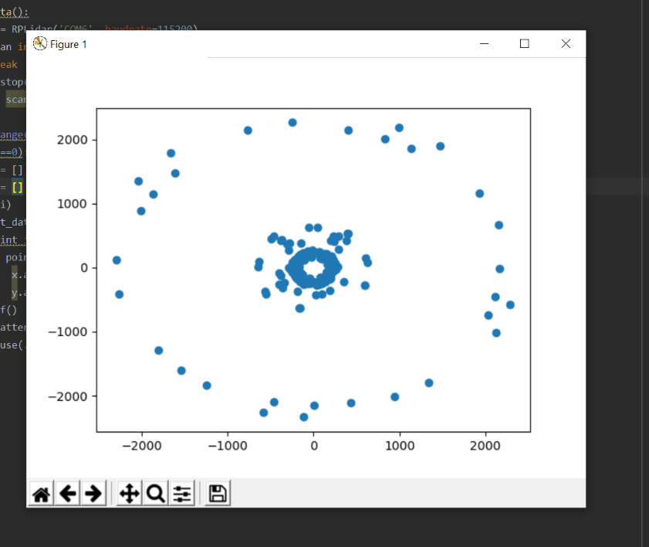

## Second system architecture.

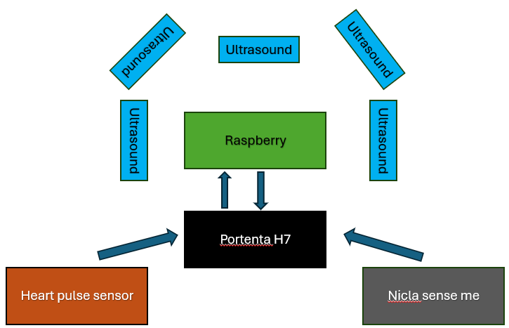

In this second architecture, the Raspberry Pi is still the main source of the computation and data logging. A second device is added to collect all the raw data, this is the Portenta H7 board. The device that can collect various type of data like motion and ambient related is the Nicla sense me board. The same pulse senor is used in this setup as the first iteration. The Lidar has been replaced by five ultrasonic sensors placed at determined angles to obtain a fast and wide view of the obstacles in the surroundings.

Portenta H7.

This is a prototyping board for industrial application. It has a dual core cortex: M7 and M4. It has 23 GPIO of which 7 are analogue.

This board was selected as it is industrial grade, and it has a dedicated support for all Nicla boards.

Its function is to collect the data by the Nicla board, the Ultrasonic sensors and the Pulse sensor. In addition, this board will detect any fault regarding the sensors.

Nicla Sense Me.

This board is responsible for collecting the following data: gyroscope, accelerometer, barometer, temperature, humidity, atmospheric pressure, and air quality.

Even tough it is possible to configure the board to perform additional tasks and use its GPIOs, it was decided to leave it to just transmit data to not overload its processor.

Ultrasonic Sensors.

The HC SR04 is being used with the availability of I2C. In this setup, the trigger and echo pins are used to initialize and retrieve data from the sensor. All the trigger pins between the sensors are shared to reduce the GPIOs used by the Portenta H7. There is a delay between the reading of each sensor as the ultrasound waves generated by the previous sensor might affect the next one. The time required to retrieve data from all five sensors is one second.

A system has been developed so that if an object is in proximity of 25 cm, the buzzer will go off.

## Second system output.

The Nicla Sense me was can successfully transmit data to the Portenta H7 which can also read the Ultrasound sensor and perform system and fault detection when the device is powered up. The Portenta H7 is connected to the Raspberry Pi via USB. In the Raspberry pi, Jupiter lab is used to develop a python algorithm to read the data transmitted by the Portenta H7. Here are the results:

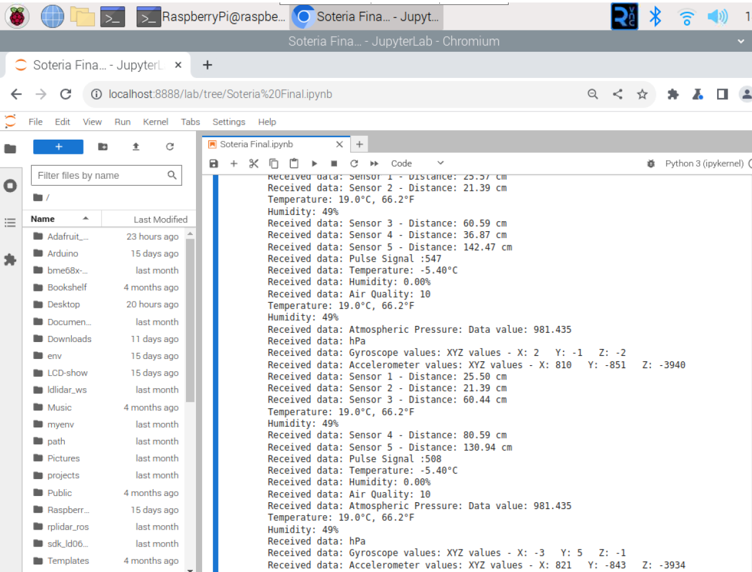

Accelerometer graph:

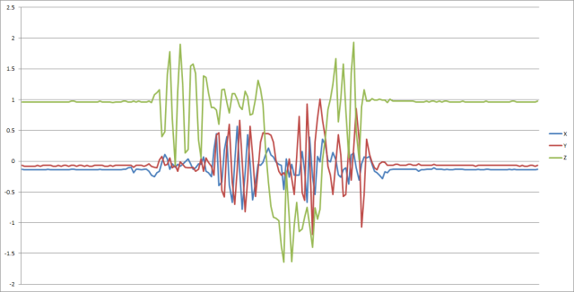

Gyroscope graph:

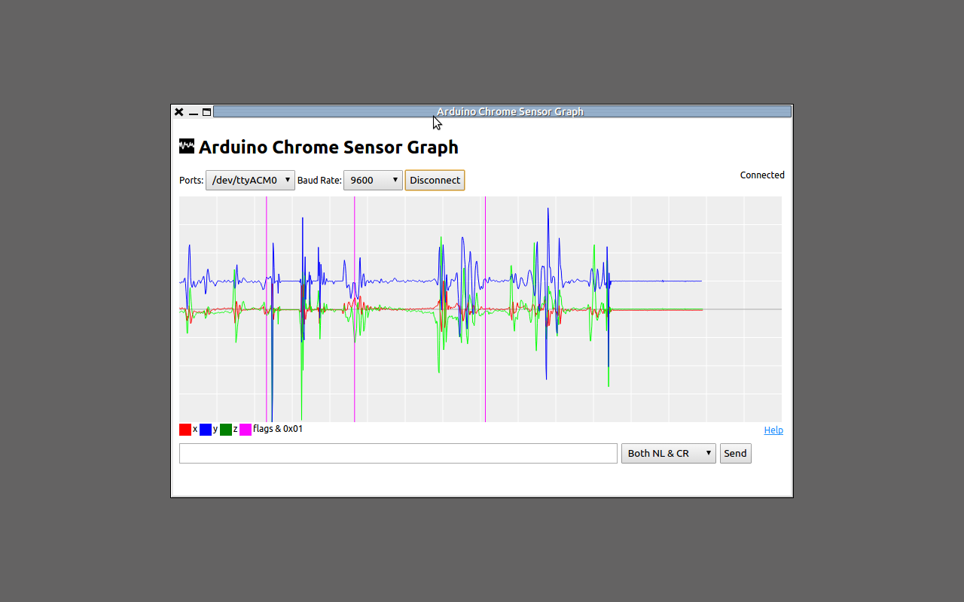

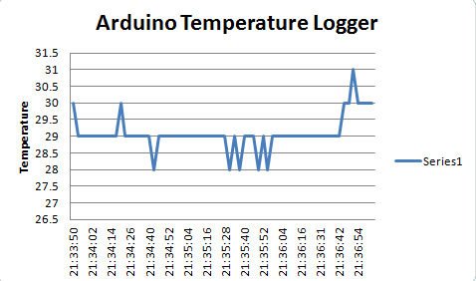

Enclosure design.

Thinkercad and Fusion 360 have been used to develop a model to hold all the parts. This enclosure is temporary as more parts will be added in the near future. Therefore, is was decided to not make it water proof and make the components fit perfectly.

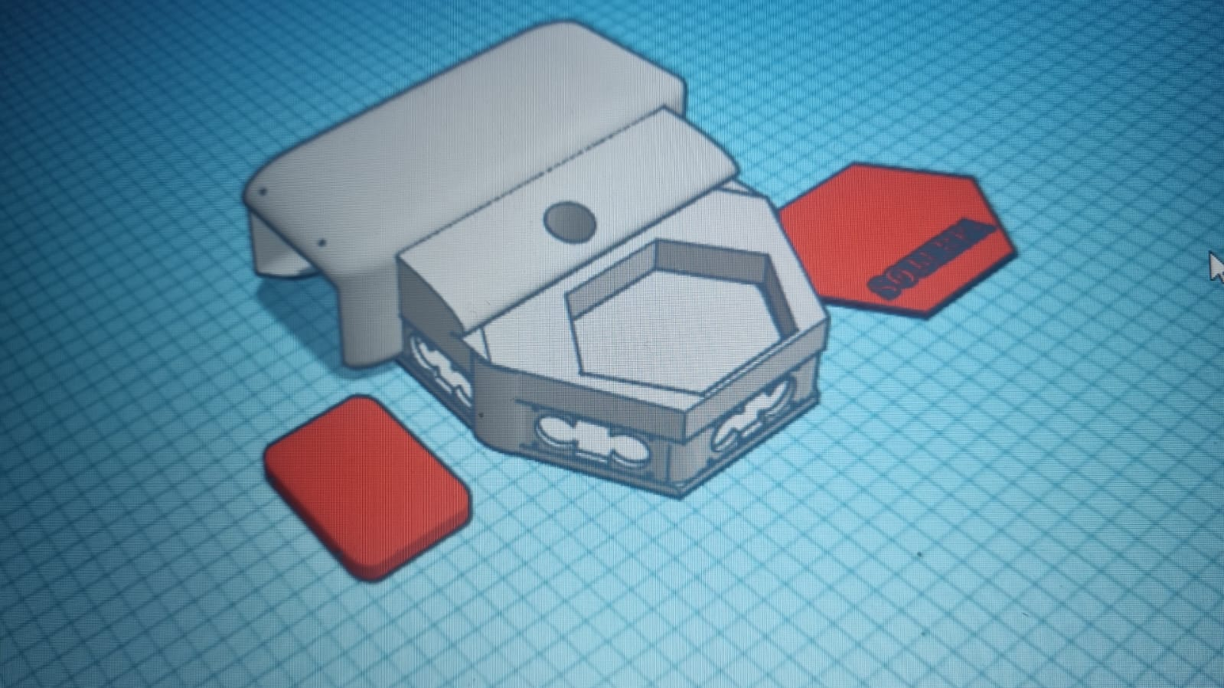

# NEXT STAGES

Now that we can collect the majority of the data required to monitor the vulnerable users’ safety, the data needs to be logged in a particular file which would be easily accessed by removing the SD card from the Raspberry pi.

The next set of information that will be collected are the users’ location and probably video and audio streaming. It is planned to connect the device to a SIM card so the device is connected to internet to access a cloud which will monitor the data of the user and provide and update necessary such as the position of unsafe locations in the users’ surroundings.

There will be changes made to the existing devices such as the development of PCB to make robust connections between components, the replacement of the pulse sensor with a sensor that is less invasive, the aim is to sense the heart rate directly from the handle of the bike.

Currently, accessing the device requires extra process to find out the IP of the device, in the future the device will have a fixed IP address.

# DEVICE USAGE METHOD

## Access to the system.

Setup the Raspberry Pi WiFi.

Once the Raspberry Pi is in the box, it is not possible to connect an external monitor to it. Therefore, it is mandatory to use an external device such as a laptop to access and control remotely the Raspberry pi. First of all, the Raspberry Pi needs to be powered, simply plug the USB type C cable between the Raspberry Pi and a power source such as a power bank.

Secondly, start the WIFI router of your laptop or mobile phone with the following details:

SSID: Soteria_Raspberry

PASSWORD: Soteria1

The Raspberry Pi should automatically connect to your hotspot. The device that is making the hotspot should notify you when that happens. If the Raspberry Pi does not connect, disconnect and reconnect power. Once the device is connected to your Wi-Fi, we can go to the next step.

Obtain the Raspberry Pi IP address.

There are many methods to see the IP address of the Raspberry Pi. On windows you can run the command in the cmd:

ping raspberrypi -4

this will give you the IP address of the device in the second line of the output.

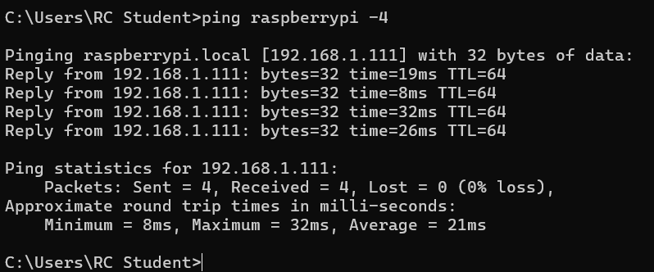

In this case is 192.168.1.1, this value can change every time the device is reset.

In case the user is on the OS X operative system, the command is:

ping raspberrypi.local

Alternatively, it is advised to download any program that can scan the IP addresses in the local network.

Remote control to the Raspberry Pi.

Once the IP address is obtained, it is possible to connect to the Raspberry Pi using a VNC app. In this setup, RealVNC was used.

Open Real VNC, in the search bar at the top insert the IP address of the Raspberry Pi. A window will appear to confirm that you want to connect to the device, after accepting, you might be required to enter the following details:

Username: RaspberryPi

Password: pi

Once done, you will be able to use the Raspberry Pi as long as it is powered and is connected to the same network as the laptop.

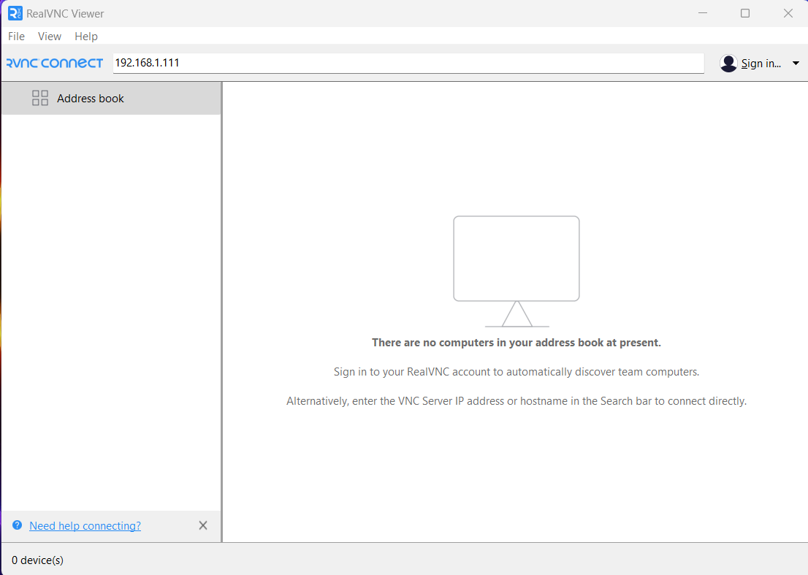

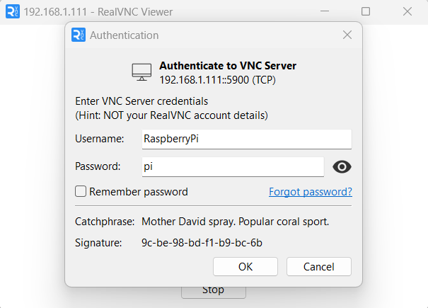

Open the data collection program.

If previous steps are completed correctly, you should have the desktop of the Raspberry Pi in front of you. You will find a text file called “useful commands”:

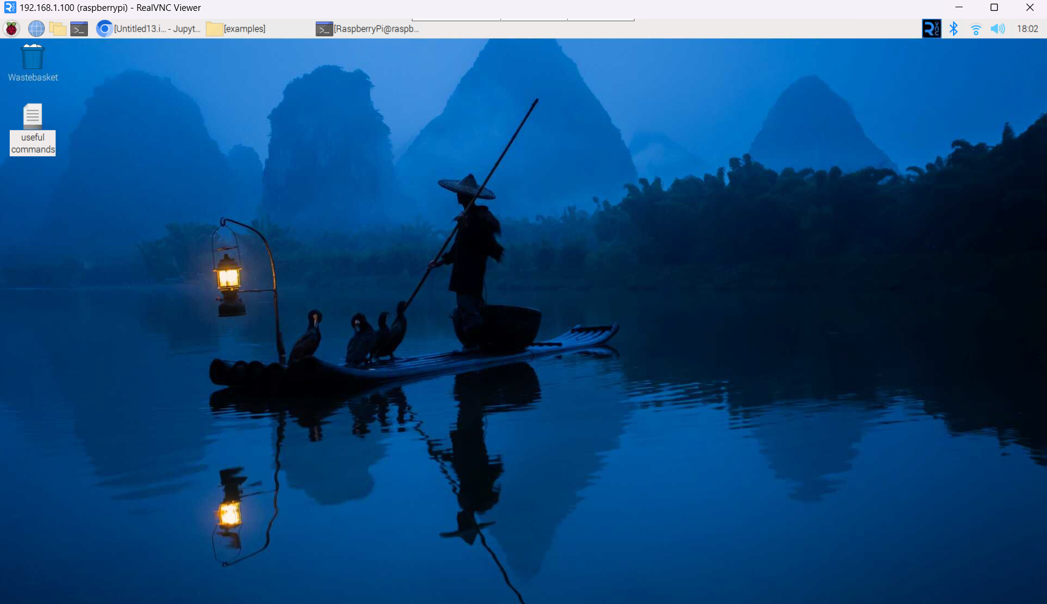

Double click it to open it and open the terminal form the top:

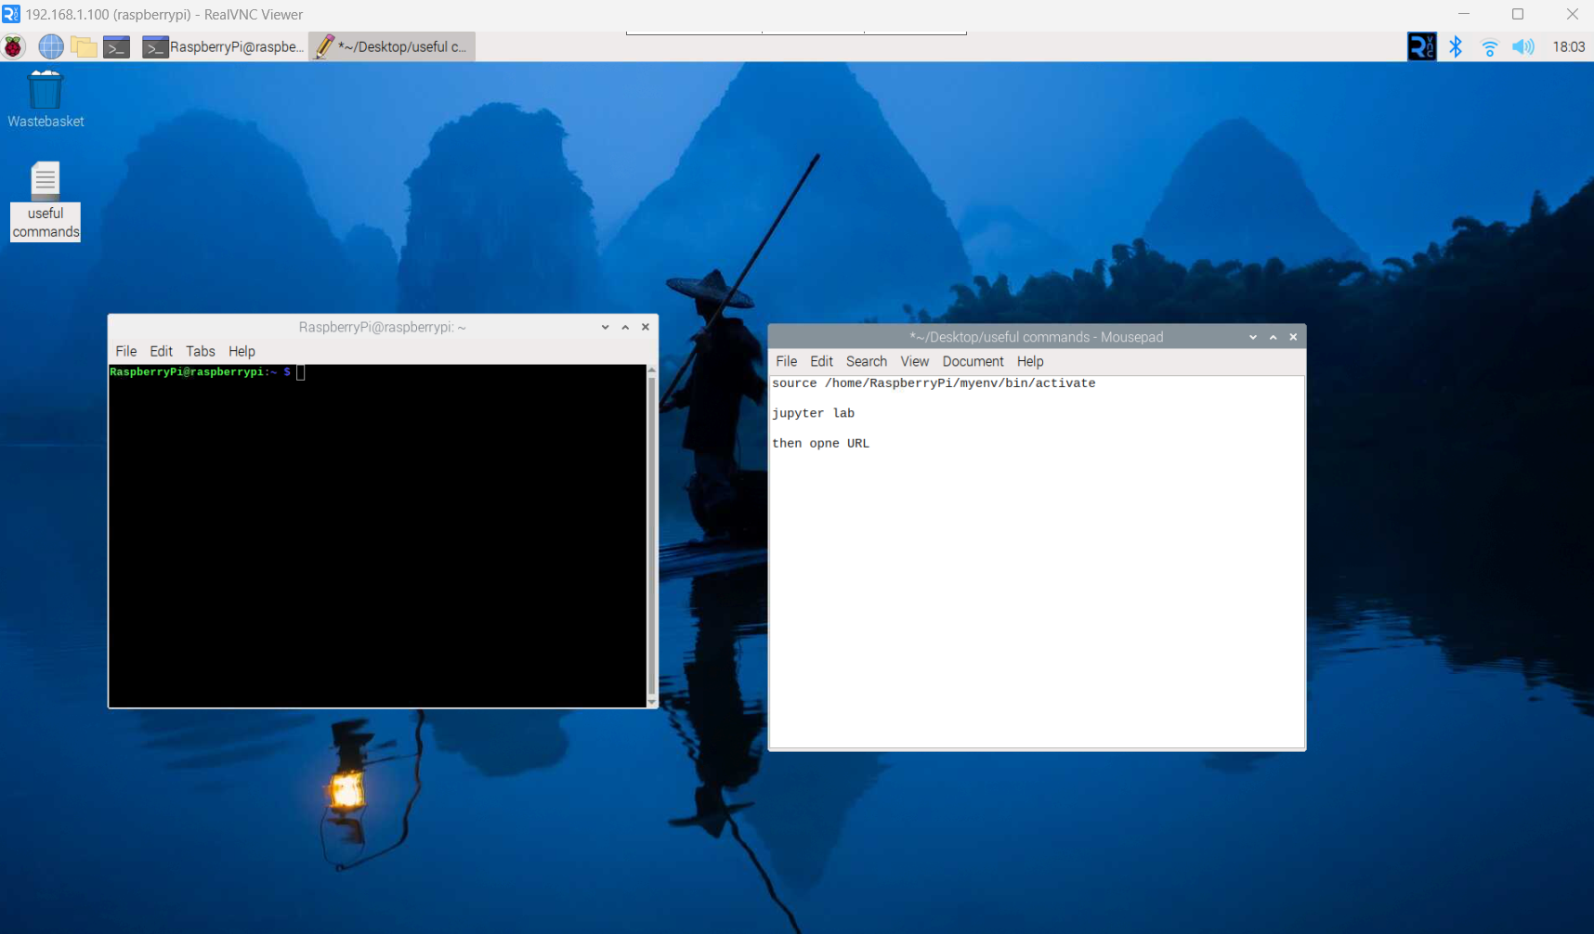

Copy and paste the first line of the text file in the terminal and press enter:

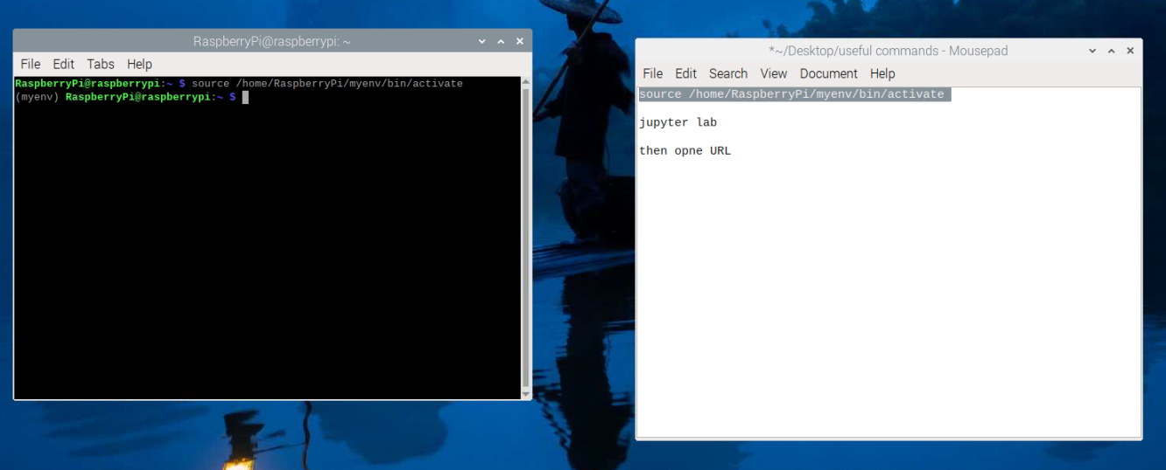

Then do the same for the second line:

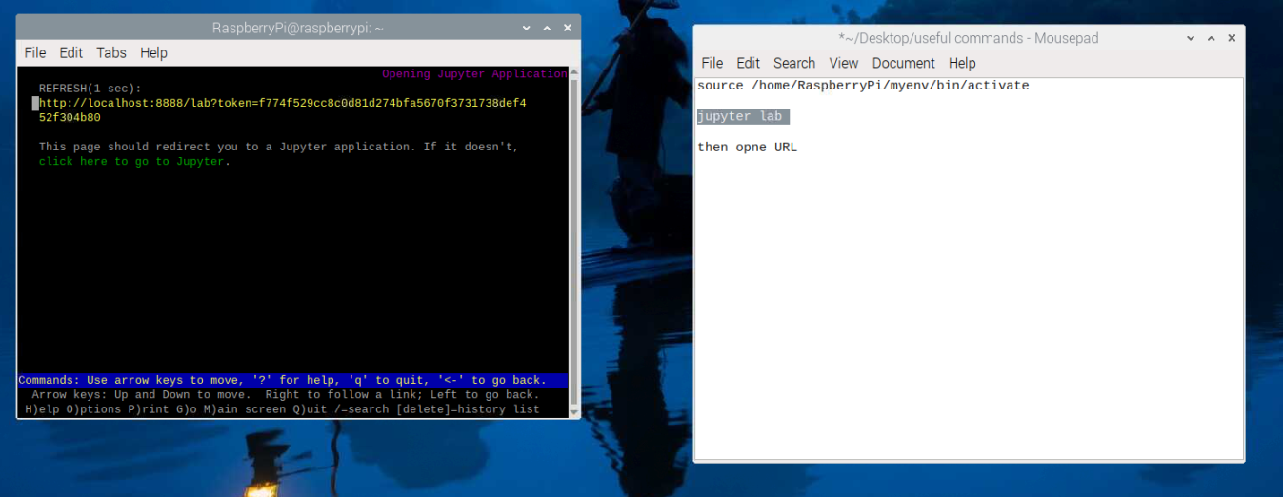

Highlight the first link (in yellow) to copy it and paste in the browser, this will open the python IDE, once done, open the “Soteria Final” file on the left side of the window:

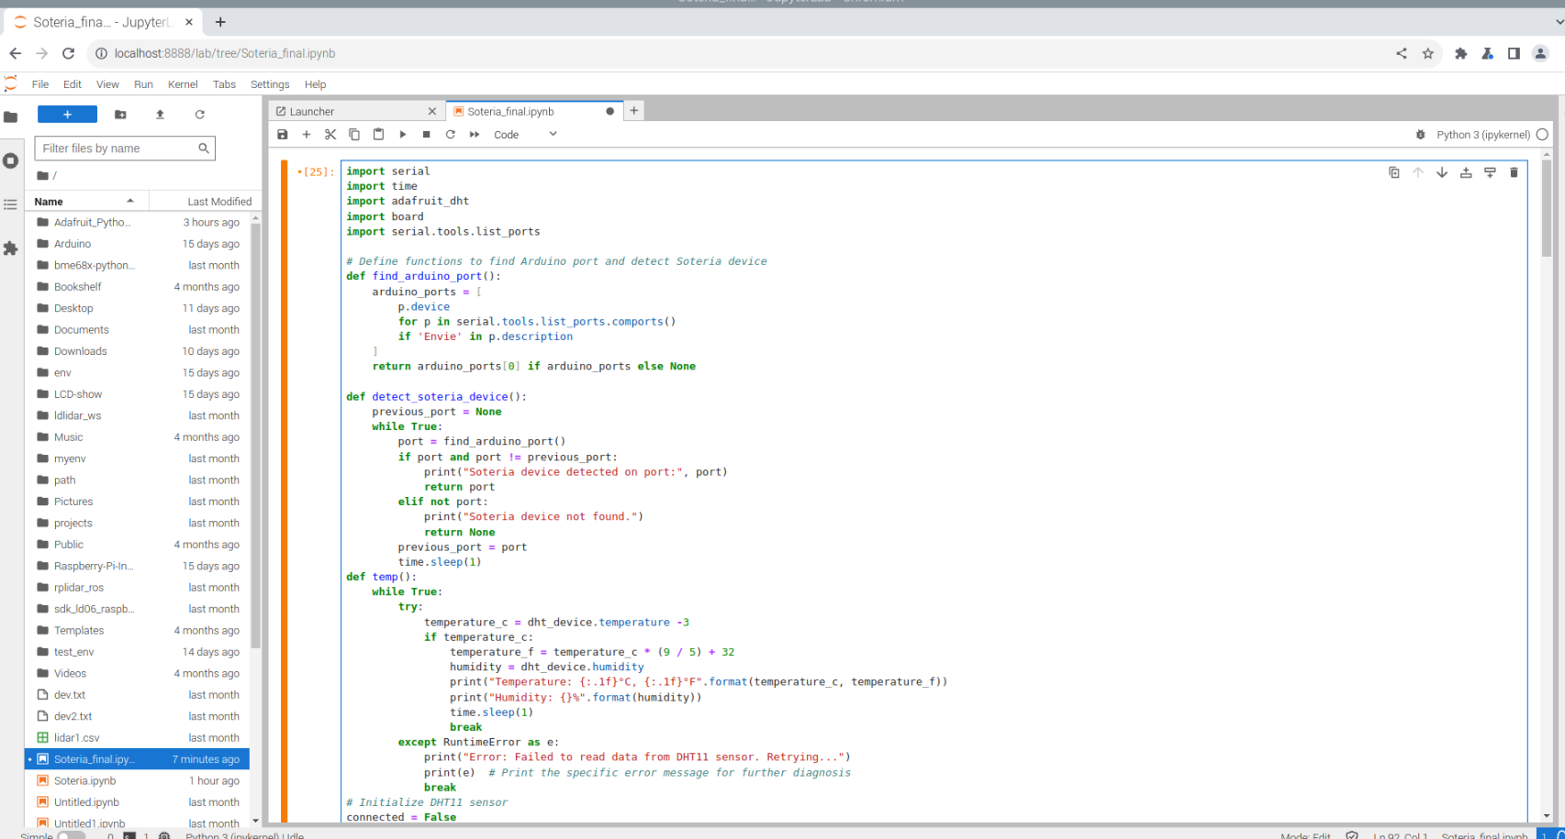

Scroll at the bottom of the code, clink on the last line and press: “Shift” + “Enter”. This will launch the code. Another method to do the same is to click anywhere in the code and press the run icon in the top bar. If the Portenta board is not connected to the Raspberry Pi via USB, an error message will be displayed. Otherwise, in case of correct connections, the following message will appear:

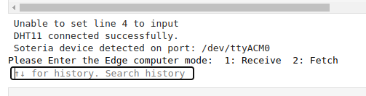

Type in the search bar “receive”, and the messages sent by the Portenta will appear.

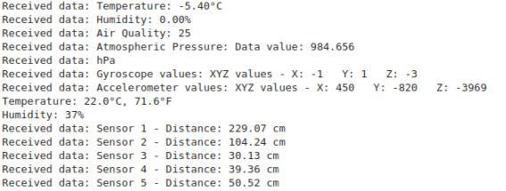

# CONCLUSION

There was not enough time to convert the static system into a portable one. Therefore, there have been issues regarding power supply and components arrangement in the enclosure. This lead to noisy data and delayed response of the overall system.